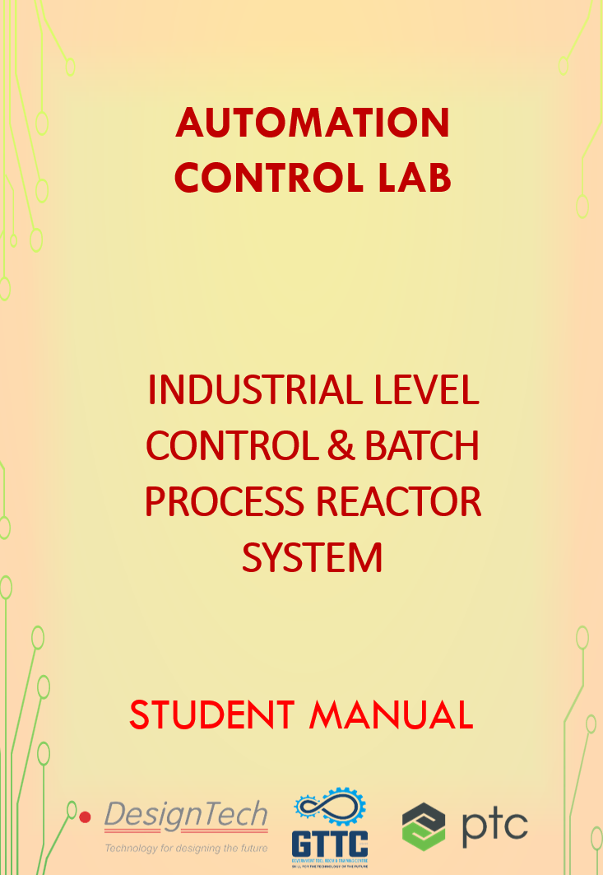

### AUTOMATION CONTROL LAB

In this lab we use different types of Automation and control techniques, we will work on the different applications according to real-time industry scenarios. Understand the role of programmable logic controllers in complex mechatronic systems, modules, and subsystems.



The list of courses offered,

|  |  |  |
| --- | --- | --- |
| **S.No** | **Name of the Course** | **Duration** |
| 1 | Basics of PLC | 50 Hours |
| 2 | Basic SCADA | 50 Hours |
| 3 | Industrial Level control and Batch Process Reactor System | 30 Hours |
| 4 | Process Instrumentation Technology | 30 Hours |
| 5 | Advance Process Control Techniques | 40 Hours |
| 6 | Advanced Industrial Electro-Pneumatic System | 40 Hours |
| 7 | Industrial Electro-Hydraulic System | 40 Hours |

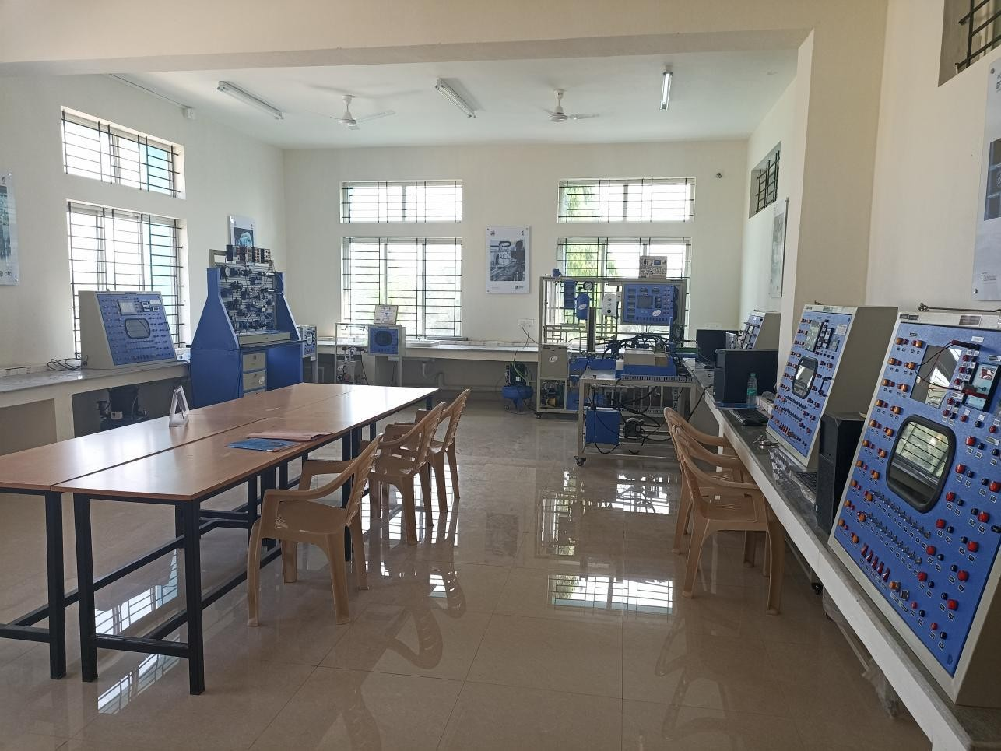

# AUTOMATION CONTROL LAB

### INDUTRIAL LEVEL CONTROL AND BATCH PROCESS REACTOR SYSTEMS

PLC based level control and batch process reactor systems offered in Automation Control Lab. In this course you will be learning about kit component like solenoid valve, level sensor, relays, sensors and electrical switches etc., also you will learn about basic programming of logo PLC. You will learn how to read electrical drawings, sensor connection with PLC etc.

|  |  |  |
| --- | --- | --- |
| **S. No** | **Name of the Course** | **Duration** |
| 1 | Industrial Level control and Batch Process Reactor System | 30 Hours |

##### Hardware equipped

PLC based Water Level control kit Batch process reactor systems LOGO PLC

##### Software: -

LOGOsoft Comfort

### Preface

It gives us an immense pleasure to interact with us via this guide. DesignTech believes in Quality at each stage. This guide shares Knowledge on Industrial Level Control and Batch Process Reactor System. It gives idea to students how to make level control and batch process systems. How to use PLC and its programming software and Give idea about all electrical connection P&I Diagram and All components in the systems.

All your suggestions and comments are most valuable for building this guide further.

  

### List of content: -

1. Course objective Page 6
2. Logo PLC Overview Page 7
3. Basics of LOGOSoft Comfort Software Page17
4. Logosoft Project creation and downloading Procedure Page30
5. Timer, counter and comparator Page43
6. PLC Based water level control Systems Page51
7. PLC Based Batch Process Reactor Systems Page61

  

### Course Objectives:

Post successful completion

Industrial Level Control and Batch Process Reactor System Course, the participant should be able to

* Understand Logo PLC basics
* Understand different blocks used in logo PLC
* Understand Industrial Level Control with real time hardware
* Understand Batch Process Reactor System
* Perform Different Example with logo PLC simulation Software.
* Understand electrical and wiring diagram
* Understand P&I diagram

### Logic Controller Overview

##### Communication with LOGO! modules by the Siemens company

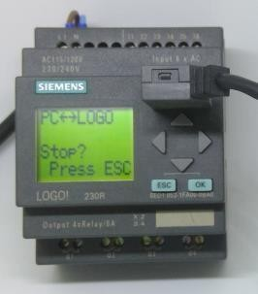

Logical modules LOGO! are suitable for both industrial usage and BMS systems. Examples of usage:

* Simple monitoring and control
* Building automation
* Remote monitoring and control of smaller machines
* Basic energy monitoring
* Location monitoring for logistics applications
* And many others

##### Communication with LOGO! 8 logical modules

The LOGO! 8 module (OBA8) supports Ethernet communication by the S7 protocol. For this communication in the PROMOTIC system can be used: **PmS7 - Driver for communication by the S7-TCP/IP protocol**

For easy integration of this driver into the application it is handy to use:

- Reconfiguration "PmS7 - LOGO! 8 - Ethernet - Communication set with data and panel"

##### Settings S7 protocol parameters for LOGO! 8:

* Communication type = Ethernet ISO on TCP Standard
* Max. PDU length = 960
* Rack = 0
* CPU Slot = 1
* Connection type = 2 = OP-connection

##### Notes concerning definition of variable address (definition of Item ID):

* The addresses in LOGO! modules start from 1, but in the S7 protocol addresses start from 0.

- Values in data areas (e.g. in I, Q, M areas, etc.) are of the Bit type, but in the S7 protocol these are of the Byte type

(i.e. 8 LOGO! values can "fit into" a single S7 value). Therefore, it is necessary to recount the LOGO! addresses when entering into S7 addresses. Example:

M1 -> M0.0 M8 -> M0.7 M9 -> M1.0

Logo PLC Expansion Module

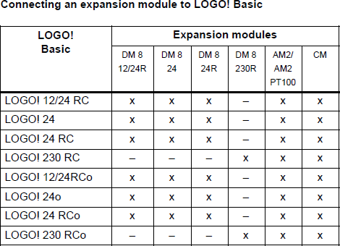

**Basic Unit**

|  |  |  |  |  |
| --- | --- | --- | --- | --- |
| **LOGO!8 – basic units** | | | | |
| **Siemens Part Code** | RS stock number | Description | Display | **Picture** |
| **6ED1052-1MD00-0BA8** | 825-1644 | LOGO! 12/24RCE | yes |  |
| **6ED1052-2MD00-0BA8** | 825-1647 | LOGO! 12/24RCEo | no |
| **6ED1052-1HB00-0BA8** | 825-1653 | LOGO! 24RCE | yes |
| **6ED1052-2HB00-0BA8** | 825-1657 | LOGO! 24RCEo | no |
| **6ED1052-1CC01-0BA8** | 825-1666 | LOGO! 24CE | yes |
| **6ED1052-2CC01-0BA8** | 825-1669 | LOGO! 24CEo | no |
| **6ED1052-1FB00-0BA8** | 825-1641 | LOGO! 230RCE | yes |
| **6ED1052-2FB00-0BA8** | **825-1650** | **LOGO! 230RCEo** | **no** |  |

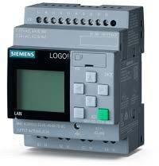**A complete range of logic modules**

* + 8 basic units for all voltages, with or without display
  + All units come with an Ethernet interface and connections are compatible with previous versions
  + Integrated web server in all basic units
  + Display features a new look and feel

|  |  |  |  |  |
| --- | --- | --- | --- | --- |
| **LOGO! 8 – digital modules** | | | | |
| **Siemens Part Code** | RS  stock number | Description | I/O | **Picture** |
| **6ED1055-1MB00-0BA2** | 825-1681 | LOGO! DM8 12/24R | 4/4 relays | Expansion Module LOGO!8 DM16 8DI/8DO |
| **6ED1055-1CB00-0BA2** | 825-1663 | LOGO! DM8 24 | 4/4 transistors |
| **6ED1055-1CB10-0BA2** | 825-1672 | LOGO! DM16 24 | 8/8 transistors |
| **6ED1055-1HB00-0BA2** | 825-1688 | LOGO! DM8 24R | 4/4 relays |
| **6ED1055-1NB10-0BA2** | 825-1685 | LOGO! DM16 24R | 8/8 relays |
| **6ED1055-1FB00-0BA2** | 825-1675 | LOGO! DM8 230R | 4/4 relays |
| **6ED1055-1FB10-0BA2** | **825-1679** | **LOGO! DM16 230R** | **8/8 relays** |

**Seven digital expansion modules**

* + Digital outputs increased to 20

**Logo PLC Expansion Module**

|  |  |  |  |  |
| --- | --- | --- | --- | --- |
| **LOGO! 8 – analogue modules** | | | | |
| **Siemens Part Code** | RS  stock number | Description | Analogue I/O | **Picture** |
| **6ED1055-1MA00-0BA2** | 825-1694 | LOGO! AM2 | 2/0  0-10V - 0/4-20mA | Expansion Module LOGO!8 AM2 12/24V 2AI |
| **6ED1055-1MD00-0BA2** | 825-1697 | LOGO! AM2 RTD | 2/0  2xPT100 or PT1000  2-wire or 3-wire |
| **6ED1055-1MM00-0BA2** | **825-1691** | **LOGO! AM2 AQ** | **0/2**  **0-10V - 0/4-20mA** |

**Three analogue expansion modules**

* + Analogue outputs increased to 8

**Logo PLC Display**

|  |  |  |  |  |
| --- | --- | --- | --- | --- |
| **LOGO! 8 – text display / panels** | | | | |
| **Siemens Part Code** | RS  stock number | Description | Supply Voltage | **Picture** |
| **6ED1055-4MH00-** | 825-1701 | LOGO! TDE | 12/24 V AC/DC | Textdisplay LOGO! TD Ethernet for LOGO!8 |
| **0BA1** |  |  |  |
| **6AV6647-0AH11-** | 746-5502 | KP300 Basic | 24V DC |
| **3AX0** |  | mono |  |
| **6AV2123-2DB03-** | 864-3967 | KTP400 Basic | 24V DC |
| **0AX0** |  |  |  |
| **6AV2123-2GA03-** | **872-6325** | **KTP700 Basic** | **24V DC** |
| **0AX0** |  |  |  |

**Displays to go with LOGO! 8**

* + - From the new 6-line text display TDE with 16 characters per line to the 7” HMI panel with colored, high resolution display the range leaves no gaps

**Logo PLC Communication Module**

|  |  |  |  |  |
| --- | --- | --- | --- | --- |
| **LOGO! 8 – communication modules** | | | | |
| **Siemens**  **Part Code** | RS  stock number | Description | Comms ports/  wireless | **Picture** |
| **6GK7177-** | 848-6213 | LOGO! CSM 12/24 | 4 x RJ45 jacks / - | LOGO! CMR2020 Communication Module |
| **1MA20-** |  |  |  |
| **0AA0** |  |  |  |
|  |  |  | **1x RJ45 jack /** |
| **SMS, GPRS, GSM** |
| **6GK7142-** | **848-6219** | **LOGO! CMR2020** |  |
| **7BX00-** |  |  |
| **0AX0** |  |  |

**Remote communications via cellular phone network**

* + - * And completely new – text message communications for alerts and remote control via cell phone using the LOGO! CMR module
      * Text messaging for active automatic alerts regarding system status
      * Position recognition and tracking via GPS, e.g. for cost effective container tracking and position reporting via text message to a central office
      * CMR2020 can exchange data with LOGO! 8, send text messages independently, and read control commands from text messages, introduce them to LOGO! 8,

and even synchronize to local time worldwide

**Logo PLC Power Module**

|  |  |  |  |
| --- | --- | --- | --- |
| **LOGO! Power** | | | |
| **Siemens**  **Part Code** | RS  stocknumber | Description | **Picture** |
| **6EP1321-1SH03** | 734-2705 | LOGO! Power 12VDC/1,9A |  |
| **6EP1322-1SH03** | 734-2708 | LOGO! Power 12VDC/4,5A |
| **6EP1331-1SH03** | 734-2714 | LOGO! Power 24VDC/1,3A |
| **6EP1332-1SH43** | 734-2718 | LOGO! Power 24VDC/2,5A |
| **6EP1332-1SH52** | **734-2727** | **LOGO! Power 24VDC/4,0A** |

**LOGOsoft comfort Software**

|  |  |  |  |
| --- | --- | --- | --- |
| **LOGO! SOFT COMFORT V8** | | | |
| **Siemens Part Code** | RS stocknumber | Description | **Picture** |
| **6ED1058-0CA08-0YE1** | 825-1708 | Upgrade | Software LOGO! SOFT COMFORT V8, Upgrade |
| **6ED1058-0BA08-0YA1** | **825-1704** | **License** |

This is the software for Logo PLC.

### Wiring Diagram of LOGO PLC

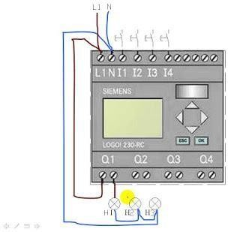

L1, N Power Supply I1…. I4 Input

Q1…Q4 Output

### Programming Software LOGOSoft Comfort

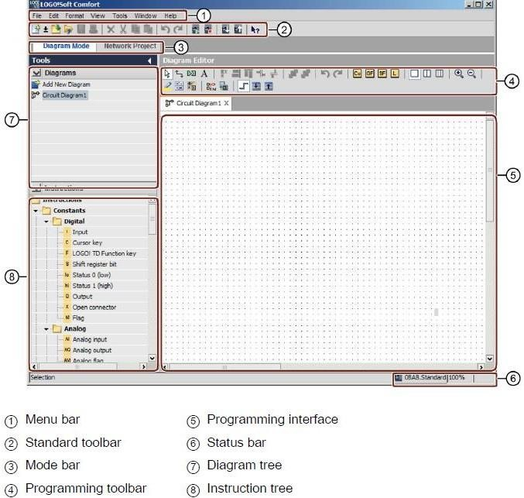

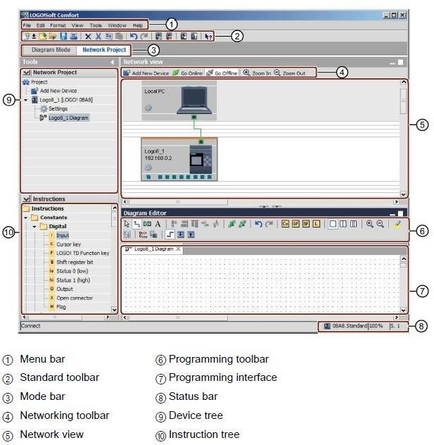

Work Area where we can do programming.

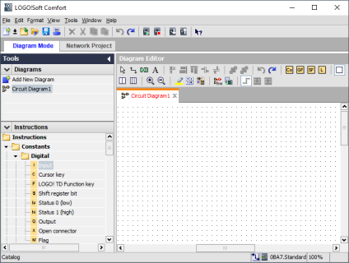

Hardware Selection

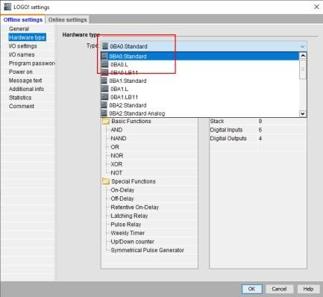

The Programming and connection with input and output of Logosoft comfort

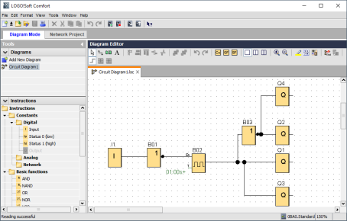

Simulation mode for testing of programming.

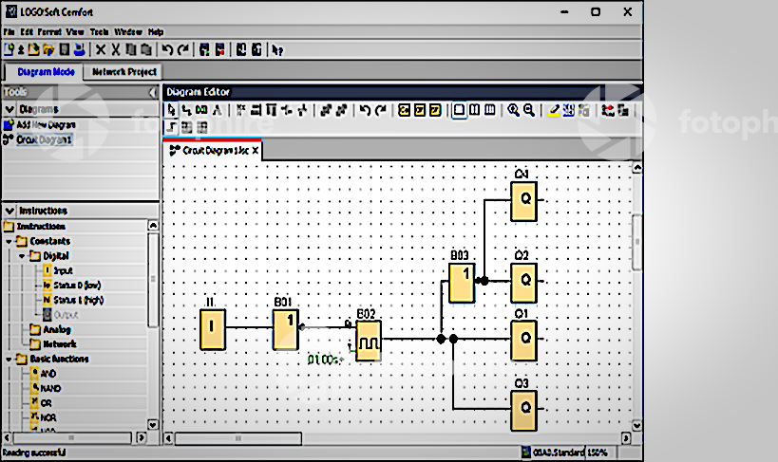

**Application Example.**

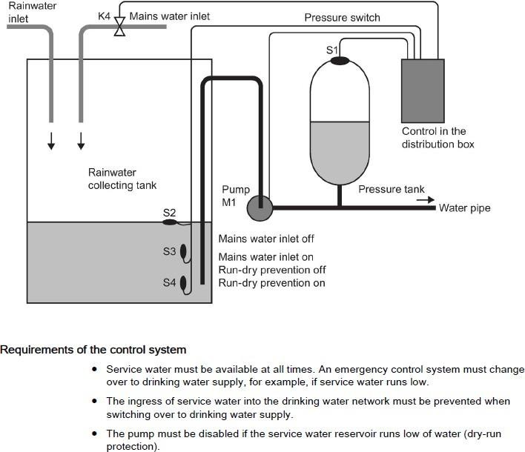

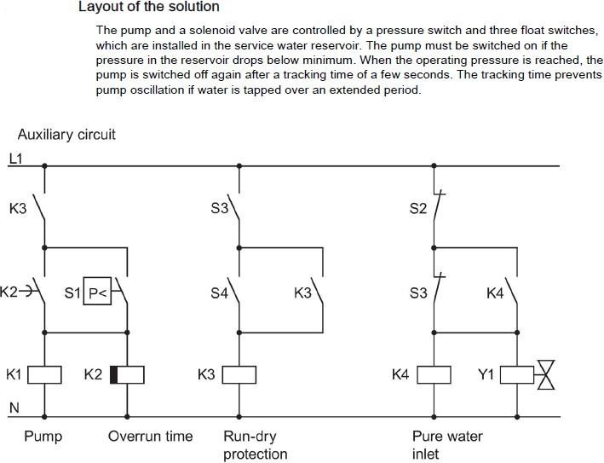

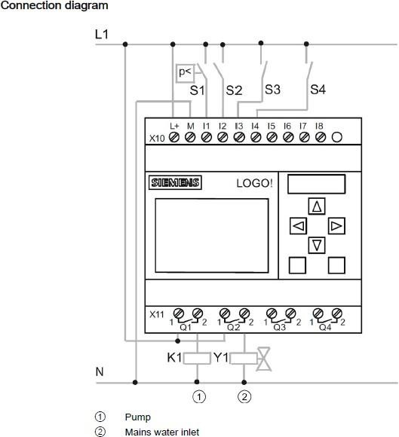

Programming

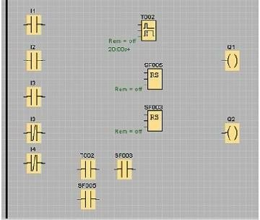

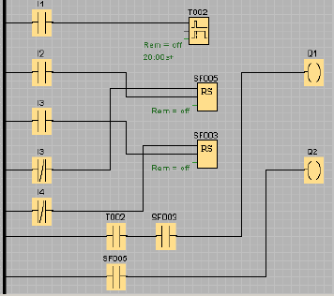

Simulation of Application

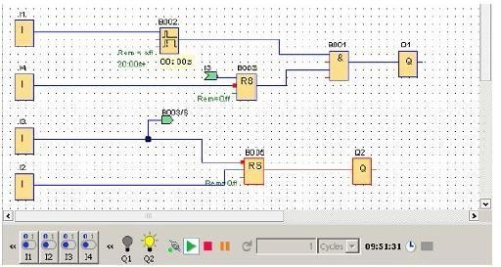

Memory Concept in LOGOSoft comfort

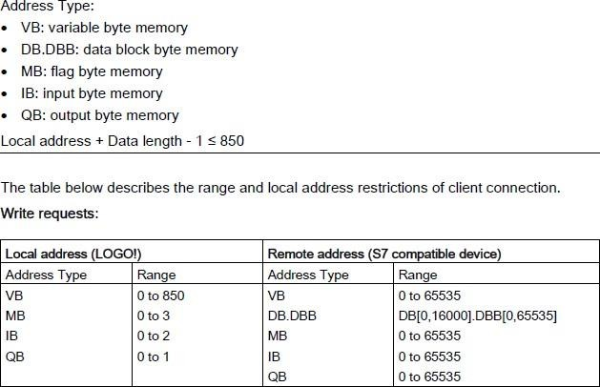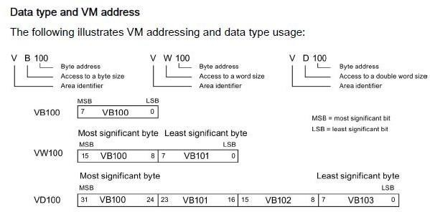

**Create and Download the PLC Program**

### Step 1: - Set the IP address in the system

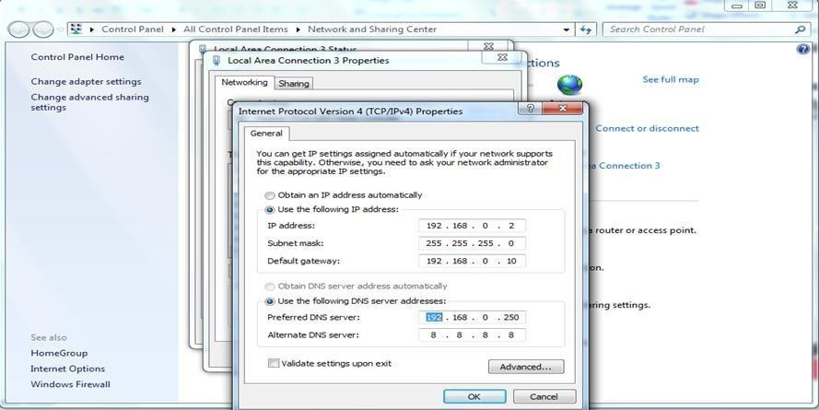

**Step 2: - Add new program**

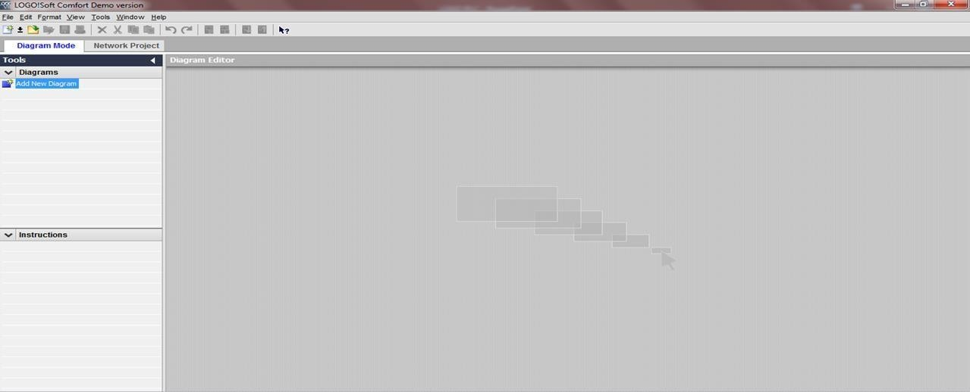

### Step 3: - For Offline setting go to Offline menu

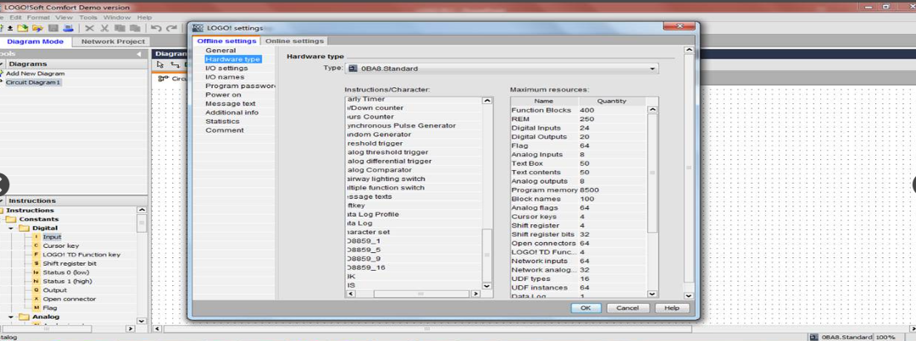

**Step 4: - Select hardware**

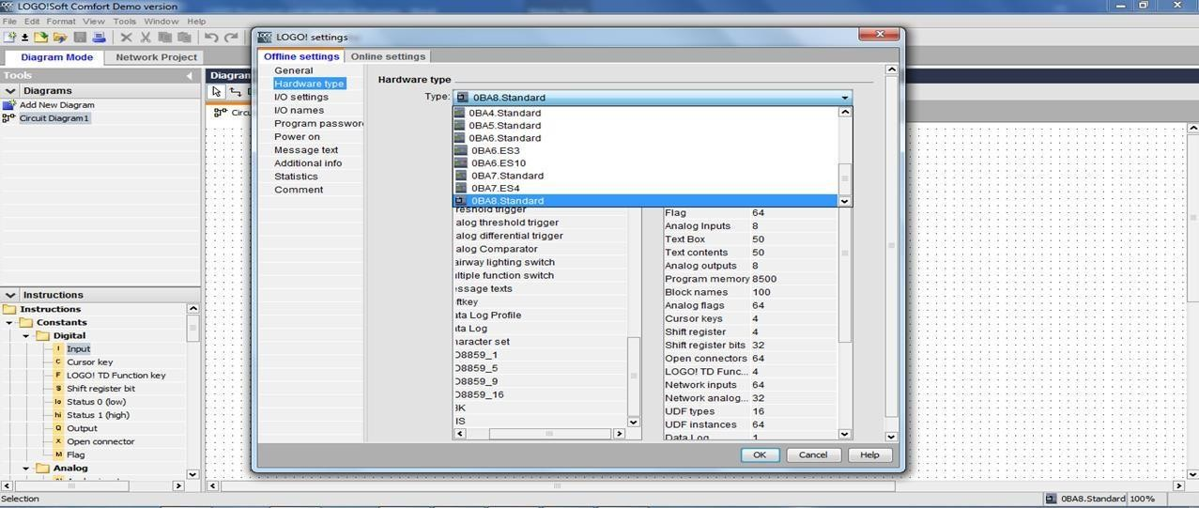

### Step 5: - Set IP Address

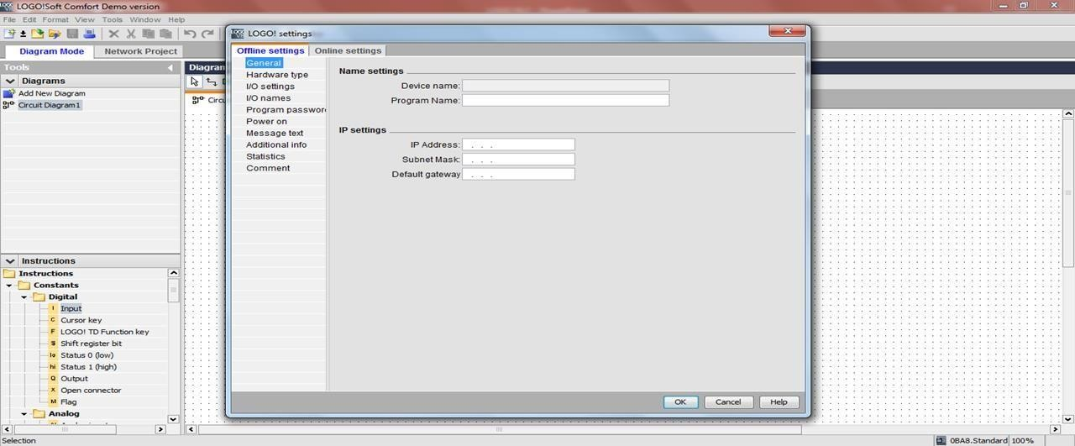

**Step 6: - Press Double Click to edit**

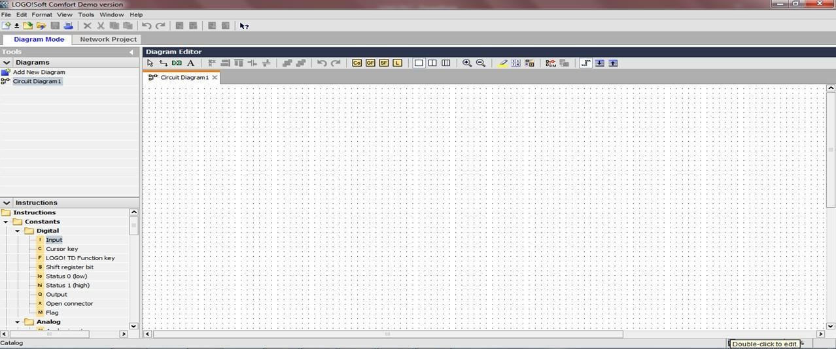

### Step7: - Online Setting Select the Ethernet

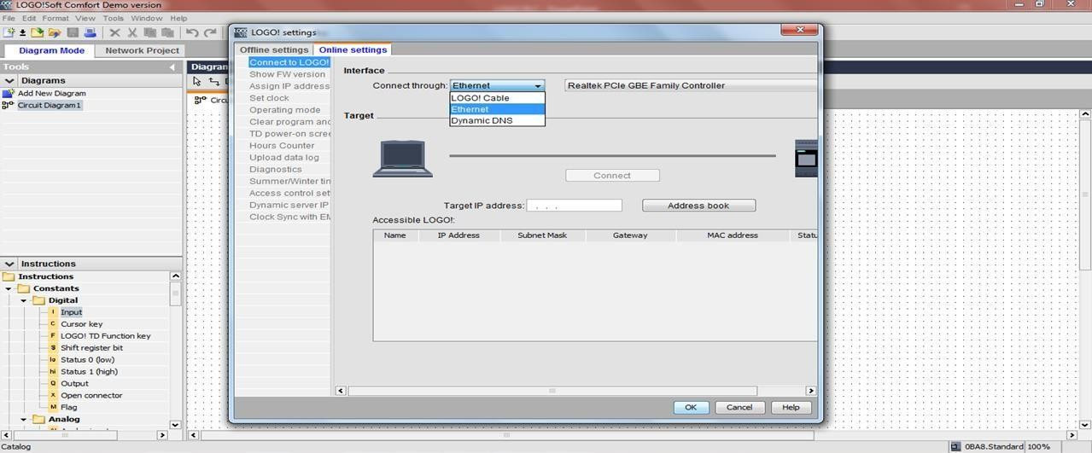

**Step 8: - Press Refresh Button it is showing device type**

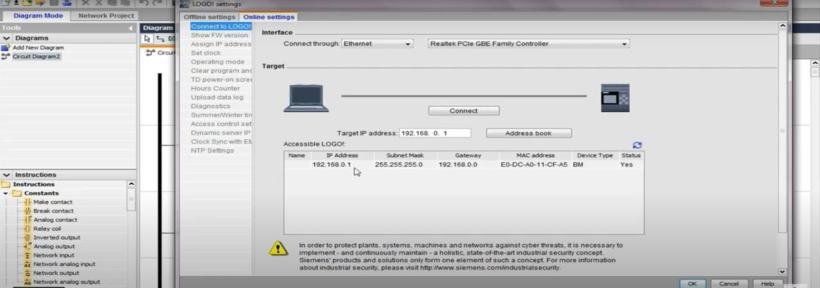

**Step 9: - Set IP Manually or Detect**

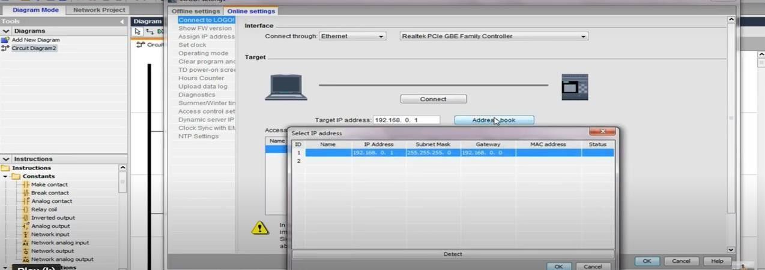

## Step 10: - Press Connect

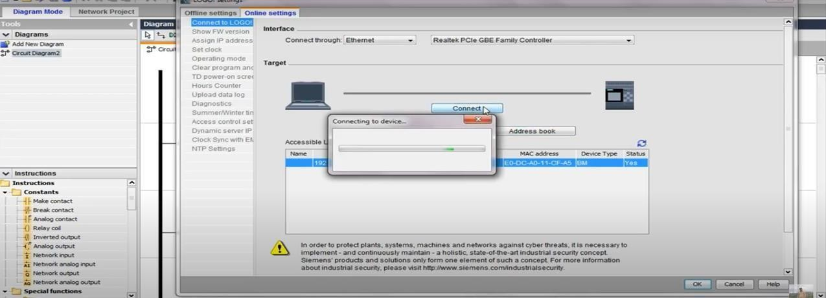

**Step 11: - Showing Green indication and Right mark**

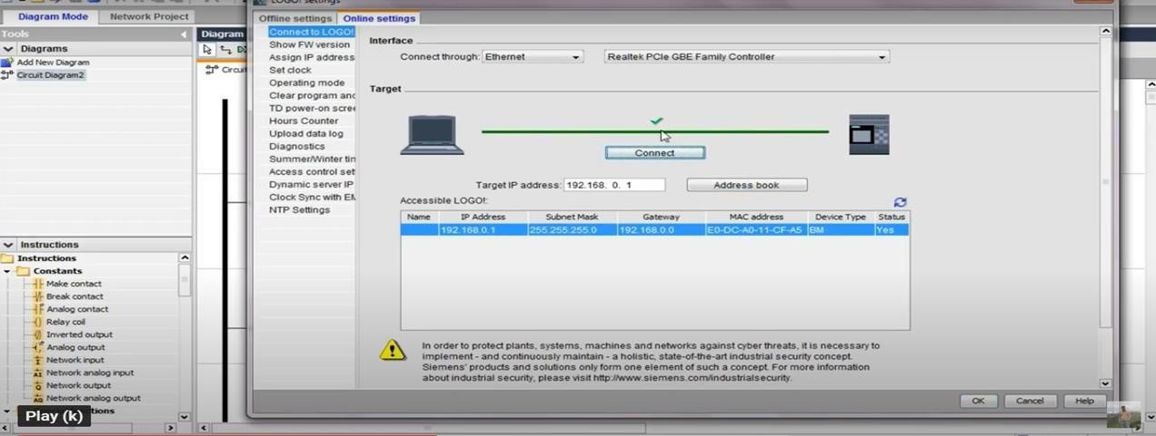

## Step 12: - Go to in diagram mode, add new Ckt. Diagram Do Programming

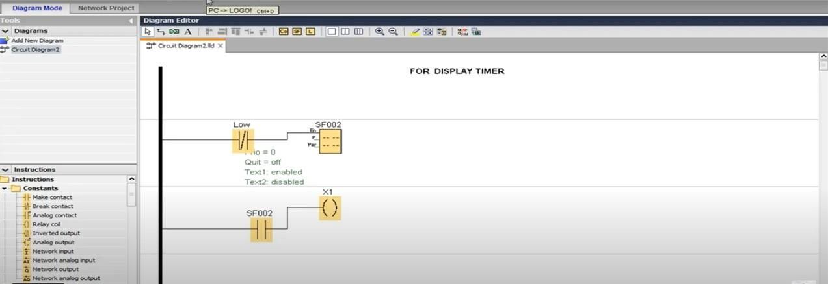

**Step 13: - Click on download option**

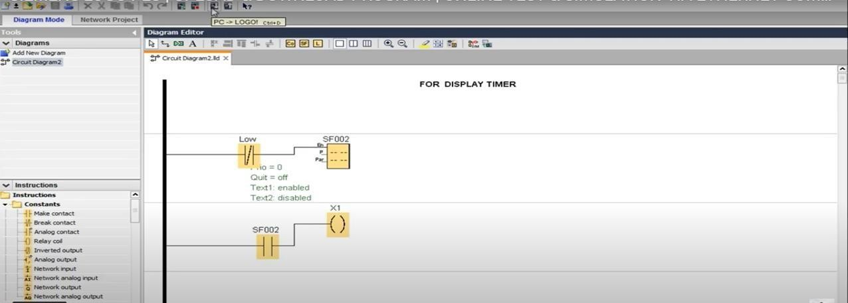

## Step 14: - Press Refresh button

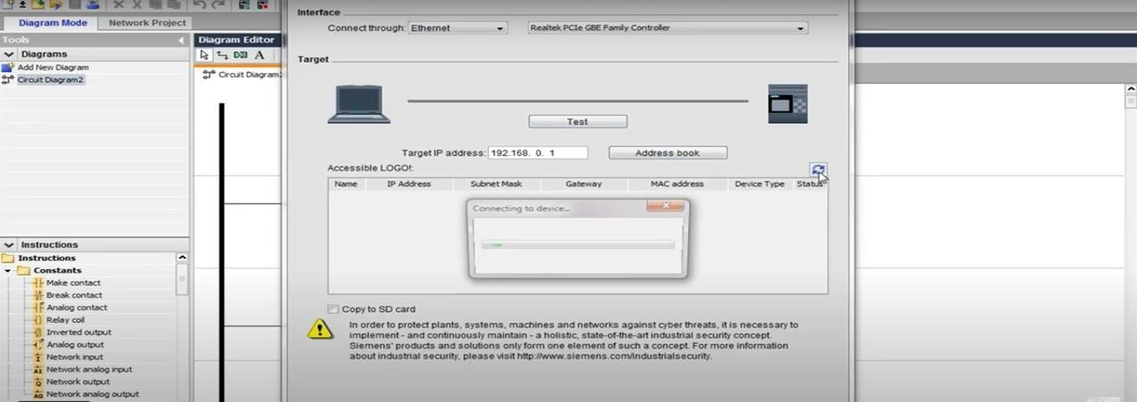

**Step 15: - Change CPU from Run to Stop while downloading**

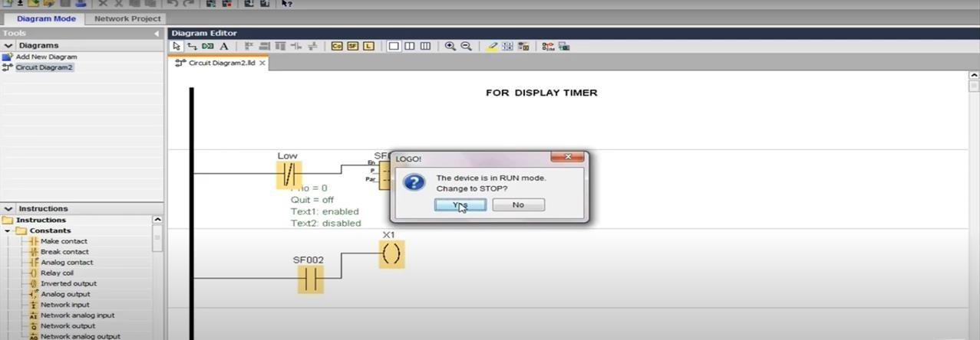

## Step 16: - Enter Password if it is password protected.

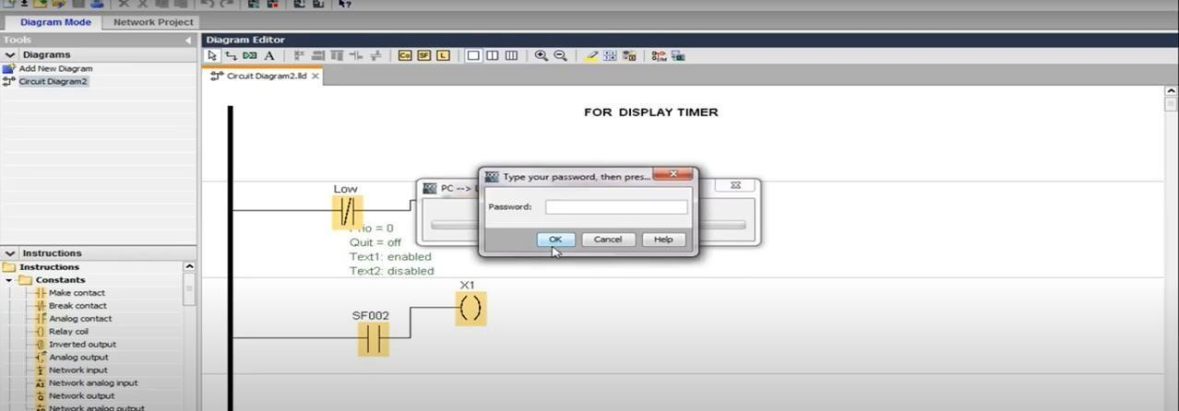

**Timer and Counter Introduction**

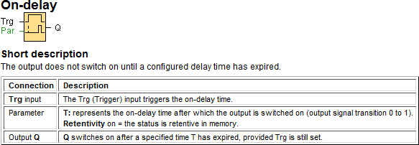

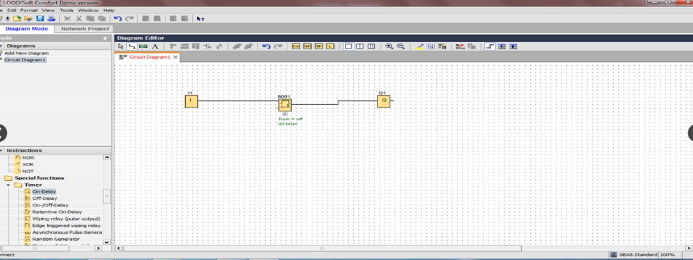

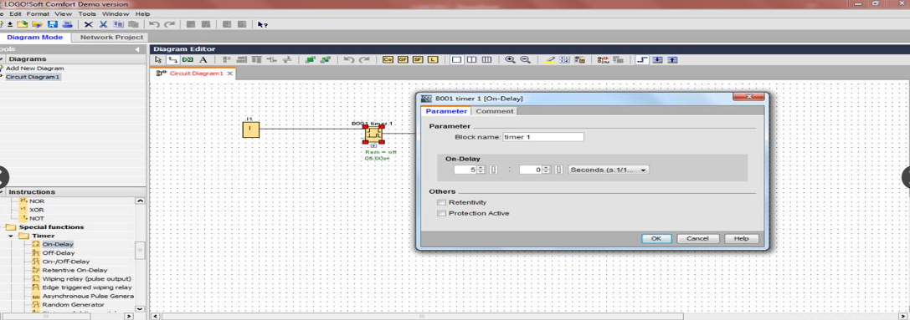

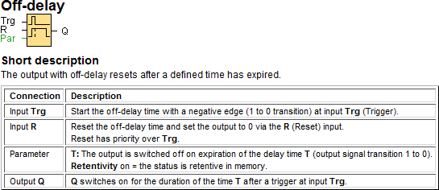

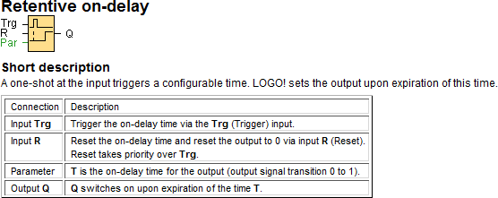

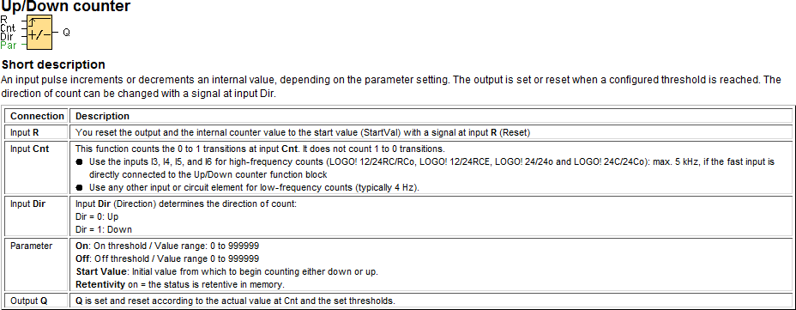

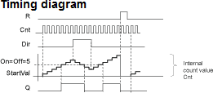

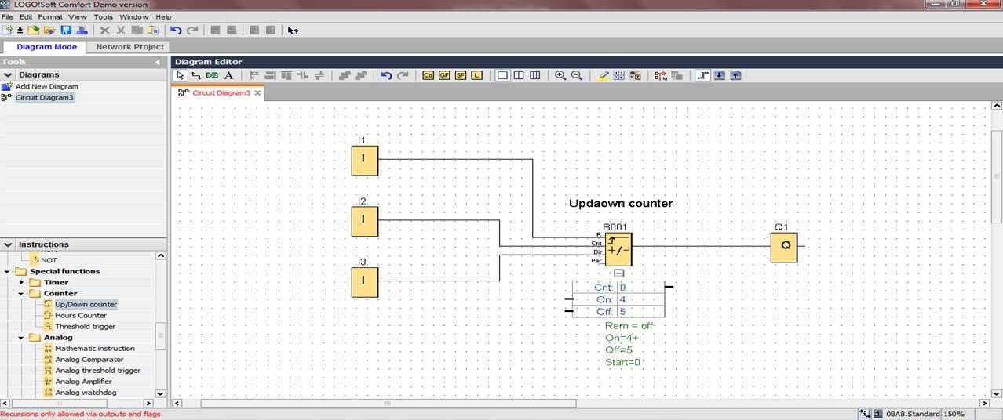



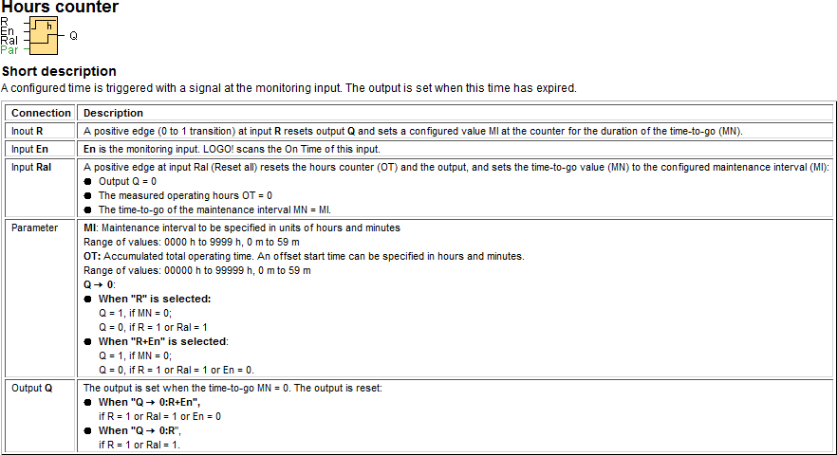

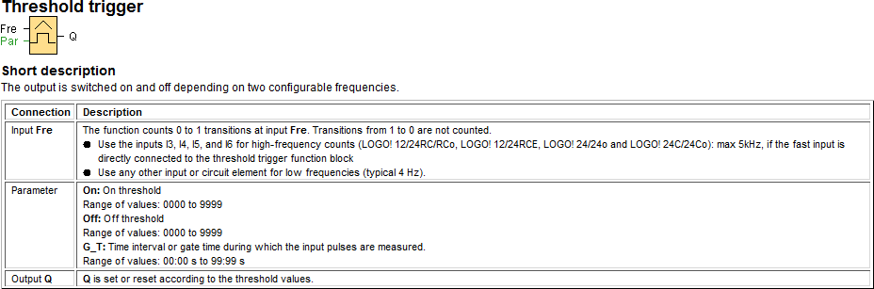

## Comparator Introduction

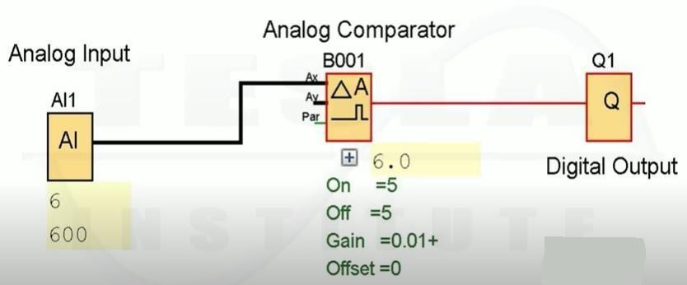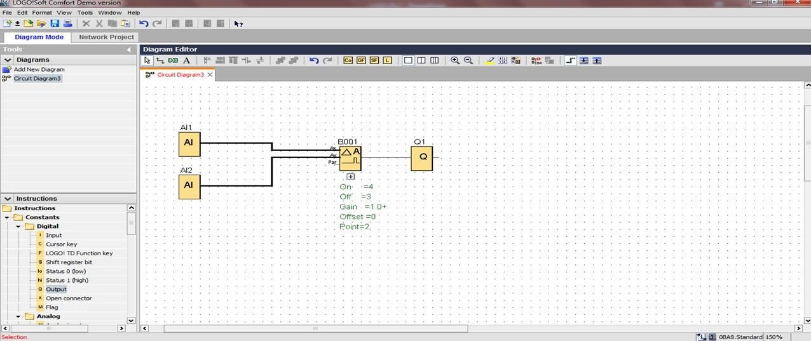

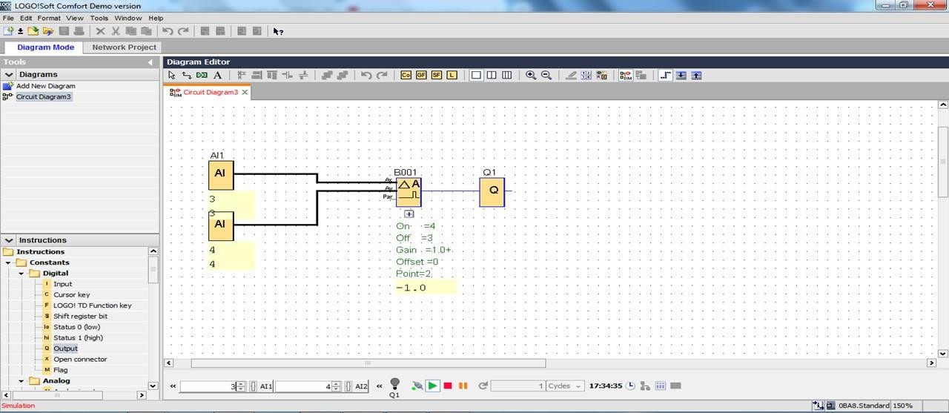

The output is set and reset, depending on the difference Ax –Ay and on two configurable thresholds

**PLC BASED WATER LEVEL CONTROL SYSTEM**

## Index

|  |  |
| --- | --- |
| **SR.NO.** | **DESCRIPTION** |
| 1 | PHOTO OF TRAINER |
| 2 | PHOTO OF WIRING |
| 3 | P&I DIAGRAM |
| 4 | SOLENOID VALVE |
| 5 | LEVEL SWITCH |
| 6 | PLC Logic |
| 8 | OPERATION |

1. **PHOTO OF TRAINER KIT: -**

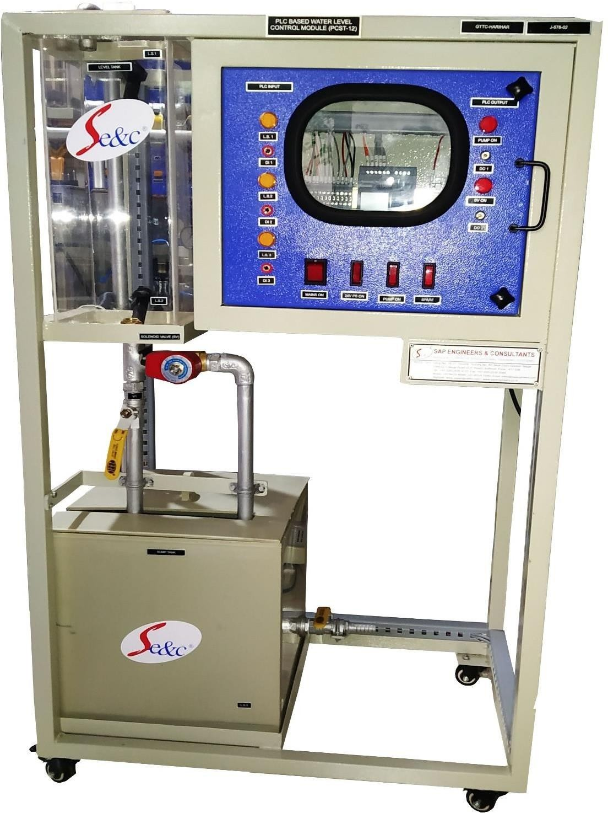

**PLC BASED WATER LEVEL CONTROL SYSTEM**

#### PHOTO OF WIRING: -

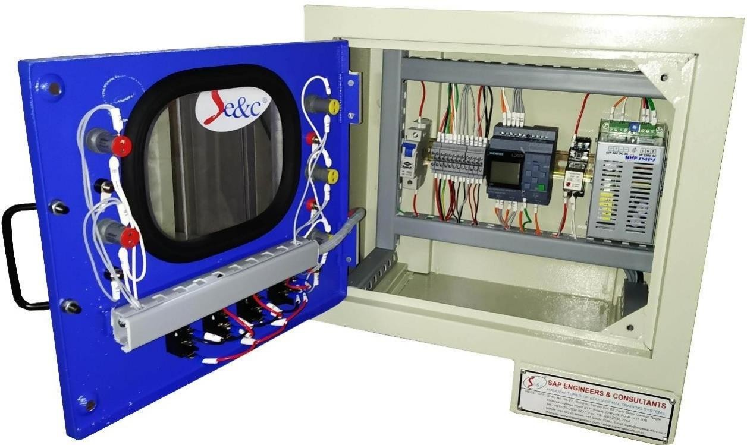

RELAY

**24V Power supply**

**PLC**

1. **P&I DIAGRAM**

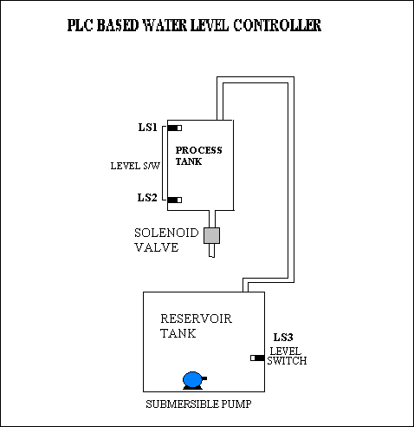

#### Solenoid Valve ST-SA 1/2&quot; brass EPDM 0-16bar 120V AC | Tameson.comSOLENOID VALVE: -

A solenoid valve is an electromechanical valve for use with liquid or gas. The valve is controlled by an electric current through a solenoid coil. Solenoid valves may have two or more ports: in the case of a two-port valve the flow is switched on or off; in the case of a three-port valve, the outflow is switched between the two outlet ports. Multiple solenoid valves can be placed together on a manifold.

A solenoid valve has two main parts: the solenoid and the valve. The solenoid converts electrical energy into mechanical energy which, in turn, opens or closes the valve mechanically.

1. **LEVEL SWITCH**

**FLOAT SWITCH:**

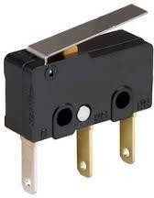

A float switch is an electro-mechanical switch which allows for an electrical switch to be opened or closed depending on the fluid level in a container. The float switch allows for automatic operation of devices depending on the level of fluid, such as the operation of pumps, or the opening or closing of valves. Float switches of numerous configurations have been used for various marine and industrial applications. Most float switches contain an electrical switch imbedded within the body of the float switch device. The electrical switch is actuated upon physical movement of the portion of the float switch device containing the electrical switch or upon physical movement of another portion of the float switch device.

##### PLC LOGIC:

Incoming control signals, or inputs, interact with instructions specified in the user ladder program, which tells the PLC how to react with the incoming signals. The user program also directs the PLC on how to control field devices like motor starters, pilot lights, & solenoids. A signal going out of the PLC to control a field device is called an Output.

The objective of the experiment is to control the water level in the tank by using PLC.

For the execution of this operation, the lower tank must be filled with water above the LS3 (level switch 3), to 75% of the reservoir. Interlocking is provided so that pump will be ON, only when LS3 is ON, avoiding dry run of the pump.

Initially turn ON all the switches, Mains ON Switch, PLC On Switch.

As LS3 (Level Switch) gets activated and LS2 (Level switch 2) is deactivated, Pump is started & remains on till level reaches LS1 (Level Switch 1) in the Level Tank.

When the level of the water in the Level Tank reaches up to LS1 (Level Switch 1), the Pump is turned off. After that 5 sec of delay occurs & the solenoid valve situated below the tank is operated and remains in operation till the level goes below to LS2 (Level Switch2).

As LS2 (Level Switch 2) level is reached, Solenoid Valve is turned OFF & the Pump is restarted to maintain water level up to LS1.

The Inputs & Outputs used in PLC are,

|  |  |  |
| --- | --- | --- |
| I/P 1: - LS-1  I/P 2:- LS-2 | Level Switch 1  Level Switch 2 | O/P1 Q1: - PUMP ON  O/P2 Q2:- SOLENOID VALVE ON |
| I/P 3:- LS-3 | Level Switch 3 |  |

#### OPERATING PROCEDURE FOR PLC BASED WATER LEVEL CONTROL MODULE

* 1. Pour / Fill 75 % of Sump Tank with Pure Water or Distilled Water
  2. Provide 230V, 50hz AC Supply to Panel

3. Switch ON Level Control Module using mains button

1. Switch On 24V DC Switch.
2. Switch ON ‘PLC ON’.
3. Wait for few seconds

##### OPERATION:

* 1. As the desired level of water reaches in the sump tank i.e above the level switch the pump gets ON.
  2. As soon as the higher level of the level tank is reached the submersible pump gets OFF
  3. As the water level of the level tank reaches the level sensor LS1, the pump gets OFF and the SOLENOID Valve gets ON
  4. As the level of the level tanks falls down below the level switch LS2, the PUMP gets ON automatically and the SOLENOID Valve turned OFF.

##### Note: Close the Ball Valve below the Level Tank and Drain Valve should be closed

8. DO’S & DON’TS FOR PLC BASED WATER LEVEL CONTROL MODULE

* + - Before starting operation of level controller ensure the water Level in the Sump Tank i.e. LS3 (Level Switch) is ON and water is filled 75% of tank level.
    - Follow operating procedure given above to perform the experiment
    - During the experiment always maintain the level of Liquid in the tank.
    - If the system is not in use for longer period, replace the water from the tank with fresh water prior performing an experiment.
    - Use clean water only.
    - Do not keep water in the tank for longer period that may damage the tank wall surface.
    - Test points on the Control Panel are for reading purpose, 24VDC input and Output.
    - If you want to Hookup this level control trainer with another PLC trainer, then turn OFF internal Siemens Logo PLC.

### PLC based Batch Process Reactor System

#### PLC BASED BATCH PROCESS REACTOR SYSTEM

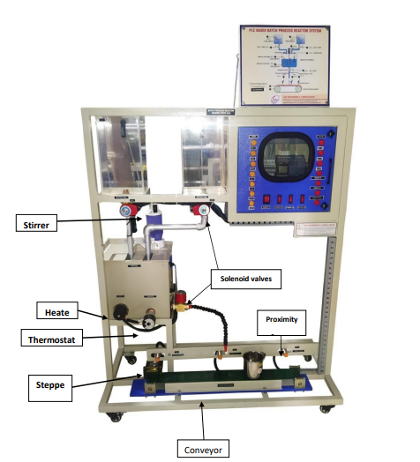

1. **PHOTOGRAPH OF PANEL**

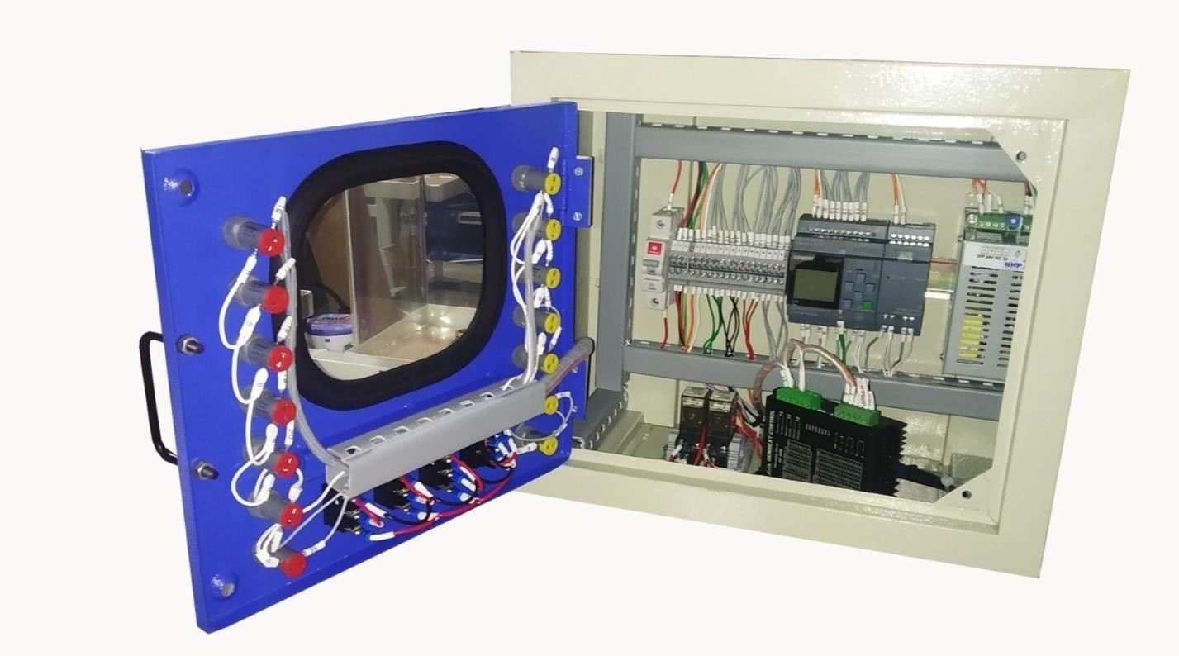

**Relays**

**Stepper Motor Drive**

**24VDC Power**

**PLC**

#### MIMIC DIAGRAM

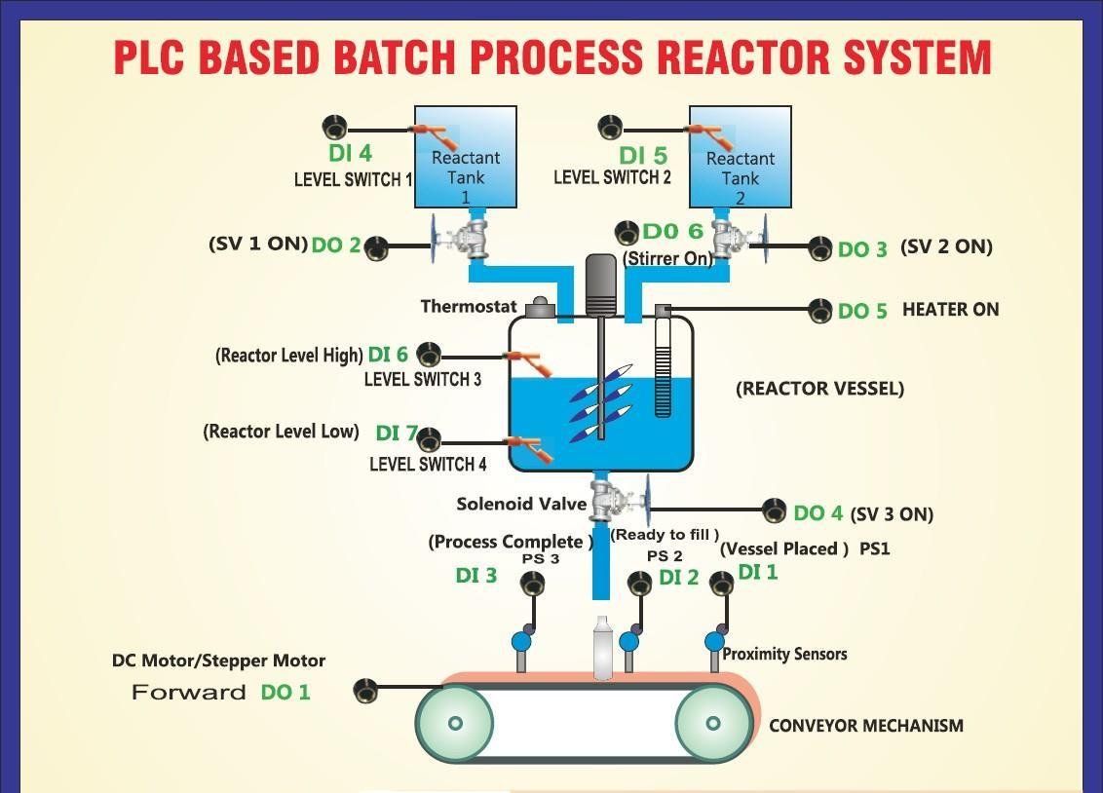

1. 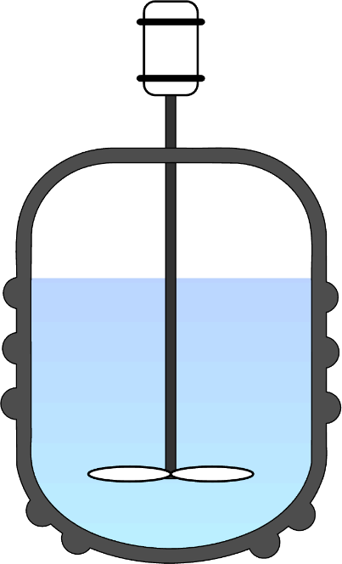**BATCH REACTOR**

A batch reactor is the simplest type of reactor vessel used for chemical or industrial processes. A typical batch reactor consists of a tank where chemical reactions occur. These tanks also have an agitator and an internal heating or cooling system. Batch Reactor vessels are used for a variety of process operations which include solids dissolution, product mixing, chemical reactions, batch distillation, crystallization, liquid/liquid extraction, and polymerization. In some cases, reactors but have a name that reflects the role they perform (such as crystallizer, or bioreactor).

A typical batch reactor consists of a tank with an agitator and an integral heating/cooling system. These vessels may vary in size from less than 1 liter to more than 15,000 liters.

They are usually fabricated in steel, stainless steel, glass-lined steel, glass, or exotic alloy. Liquids and solids are usually charged via connections in the top cover of the reactor. Vapors and gases also discharge through connections in the top. Liquids are usually discharged out of the bottom.

One of the biggest advantages of the batch reactor is that a single vessel can carry out a sequence of different operations without the need to break containment which is useful when processing, toxic or highly potent compounds.

#### SYSTEM COMPONENTS

* 1. PROCESS TANK: A process tank is a vessel or other container used for the mixing or batching of chemicals, feeds, wastewater, or other components, or for the preparation of one or more components, leading to the production of the desired product. The term includes all attached piping and other fixtures necessary for the intended operation of the vessel or container.
  2. STIRRER/AGITATOR: An Agitator/Stirrer is used for mixing different process media
     + liquids, gases, and solids in chemical addition or Pharmaceutical Ingredients. The agitator imparts energy through mechanical means by rotating a shaft on which there is an impeller designed specifically for the duty. This could be axial pumping, gas induction, flocculating, high viscosity products, high & low shear mixing, etc. An agitator is also used in the Water Industry for adding various chemicals to bring the source water up to drinking water standards. The usual agitator arrangement is a centrally mounted [driveshaft](http://en.wikipedia.org/wiki/Driveshaft) with an overhead drive unit. [Impeller](http://en.wikipedia.org/wiki/Impeller) blades are mounted on the shaft. A wide variety of blade designs are used and typically the

blades cover about two-thirds of the diameter of the reactor. Where viscous products are handled, anchor-shaped paddles are often used which have a close clearance between the blade and the vessel walls. Most batch reactors also use [baffles.](http://en.wikipedia.org/wiki/Baffle_(in_vessel)) These are stationary blades that break up flow caused by the rotating agitator. These may be fixed to the vessel cover or mounted on the interior of the side walls. Despite significant improvements in agitator blade and baffle design, mixing in large batch reactors is ultimately constrained by the amount of [energy](http://en.wikipedia.org/wiki/Energy) that can be applied. An Agitator is generally made up of three main components

* + - a shaft with impellers, a mechanical seal, and a motor with the option of gearbox for lower RPM duties. The agitator is mounted onto the vessel or via a supporting bridge in the water industry. The mechanical seal has several options depending on the duty – single/double mechanical seal, dry or wet mechanical seal, gas lift-off mechanical seal that is related to the duty involved. An agitator shaft is connected to the drive unit (motor & gearbox) and where the impellers used for the mixing are welded or bolted onto.
  1. HEATING SYSTEM: Products within batch reactors usually liberate or absorb [heat](http://en.wikipedia.org/wiki/Heat) during processing. Even the action of stirring stored liquids generates heat. To hold the reactor contents at the desired [temperature,](http://en.wikipedia.org/wiki/Temperature) heat has to be added or removed by a [cooling jacket](http://en.wikipedia.org/wiki/Heat_exchanger) or [cooling pipe.](http://en.wikipedia.org/wiki/Heat_pipe) Heating/cooling coils or external jackets are used for heating and cooling batch reactors. Heat transfer fluid passes through the jacket or coils to add or remove heat.
  2. REACTOR/LEVEL TANKS: The liquid before entering the process tank is stored in the level tanks. Their capacity depends upon the capacity of the Process Tank. Level switches are mounted on these level tanks so that the desired amount of liquid is transferred to the Process Tank.
  3. 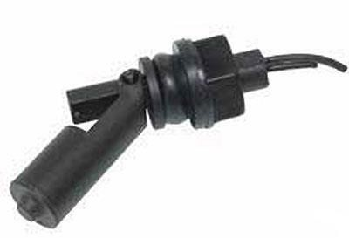LEVEL/FLOAT SWITCHES: A float switch is an electromechanical switch that allows for an electrical switch to be opened

or closed depending on the fluid level in a container. The float switch allows for automatic operation of devices depending on the level of fluid, such as the operation of pumps, or the opening or closing of valves. Float switches of numerous configurations

have been used for various marine and industrial applications. Most float switches

contain an electrical switch embedded within the body of the float switch device. The electrical switch is actuated upon physical movement of the portion of the float switch device containing the electrical switch or upon physical movement of another portion of the float switch device.

* 1. 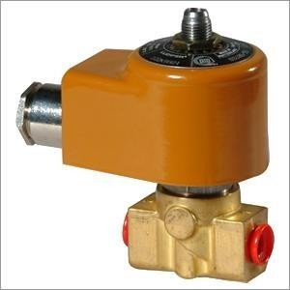SOLENOID VALVES **(**24V DC operated ½” size): A solenoid valve is an electrically controlled valve. The valve features a solenoid, which is an electric coil with a movable ferromagnetic core (plunger) in its center. In the rest position, the plunger closes off a small orifice. An electric current through the coil creates a magnetic field. The magnetic field exerts an upwards force on the plunger opening the orifice. This is the basic principle that is used to open and close solenoid valves.

A solenoid valve has two main parts: the solenoid and the valve. The solenoid converts electrical energy into mechanical energy which, in turn, opens or closes the valve mechanically.

* 1. 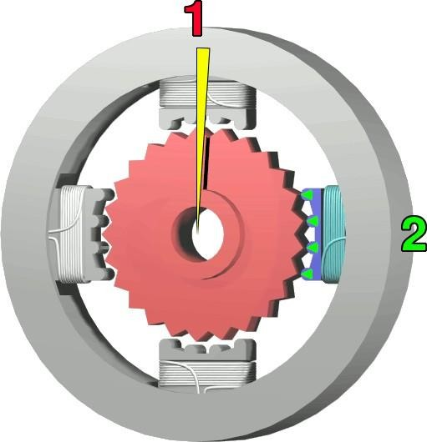STEPPER MOTOR: A stepper motor is an electric motor whose main feature is that its shaft rotates by performing steps, that is, by moving by a fixed number of degrees. This feature is obtained thanks to the internal structure of the motor and allows to know the exact angular position of the shaft by simply counting how many steps have been performed, with no need for a sensor. This feature also makes it fit for a wide range of applications. Stepper motors, on the other hand, effectively have multiple "toothed" electromagnets arranged around a

central metal gear, as shown at right. To make the motor shaft turn, first one electromagnet is given power, which makes the gear's teeth magnetically attracted to the electromagnet's teeth. When the gear's teeth are thus aligned to the first electromagnet, they are slightly offset from the next electromagnet. So, when the next electromagnet is turned on and the first is turned off, the gear rotates slightly to align with the next one, and from there the process is repeated. Each of those slight rotations is called a "step." In that way, the motor can be

turned at a precise angle. There are two basic arrangements for the electromagnetic coils: bipolar and unipolar.

The top electromagnet (1) is charged, attracting the topmost four teeth of sprocket.

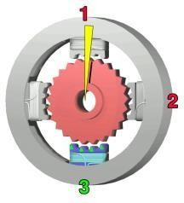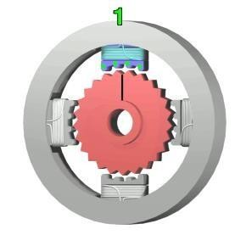

a

is

of

The top electromagnet (1) is turned off, and the right electromagnet (2) charged, pulling the nearest four teeth to the right. This results in a rotation 3.6°.

The bottom electromagnet (3) is charged; another 3.6° rotation occurs.

The left electromagnet (4) is enabled, rotating again by 3.6°. When the top electromagnet (1) is again charged, the teeth in the sprocket will have rotated by one tooth position; since there are 25 teeth, it will take 100 steps to make a full rotation.

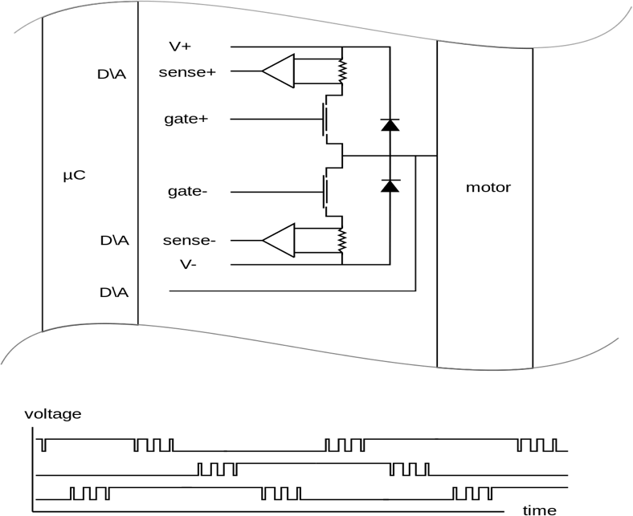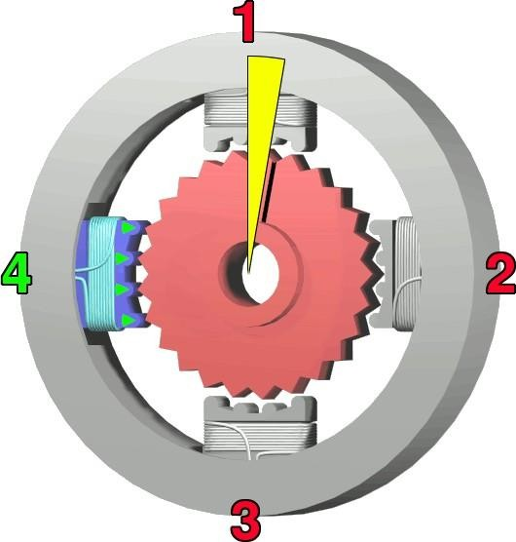

requirements, and temperature management some glue circuitry is necessary between digital controller and motor.

Because of induction of the windings, power

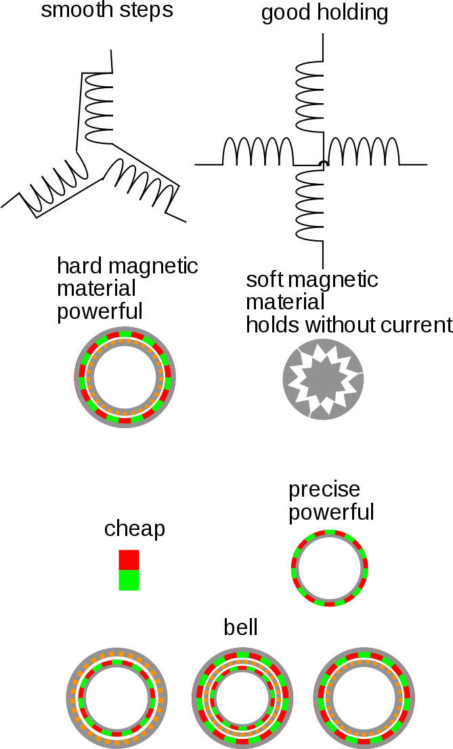

Different details of configuration have to be decided when choosing a motor. Almost everything is combinable.

* 1. PROXIMITY SWITCH: A **proximity switch** is one detecting the proximity (closeness) of some object. By definition, these switches are non-contact sensors, using magnetic, electric, or optical means to sense the proximity of objects. A proximity switch will be in its “normal” status when it is distant from any detectable object. Being non- contact in nature, proximity switches are often used instead of direct-contact limit switches for the same purpose of detecting the position of a machine part, with the advantage of never wearing out over time due to repeated physical contact. Most proximity switches are active in design. That is, they incorporate a powered electronic circuit to sense the proximity of an object. Inductive proximity switches sense the presence of metallic objects through the use of a high-frequency magnetic field. Capacitive proximity switches sense the presence of non-metallic objects through the use of a high-frequency electric field. Optical proximity switches detect the interruption of a light beam by an object. Ultrasonic proximity switches sense the presence of dense matter by the reflection of sound waves.

Operating Principle: These types of switches work on the “Damped Oscillator” principle. During operation, a frontally radiated electromagnetic oscillating field is projected from the sensing face. Any Electrically conductive material entering this field causes damping of the oscillations. This change is detected by the in-built sensitive & reliable electronic circuit and is converted into an effective output signal.

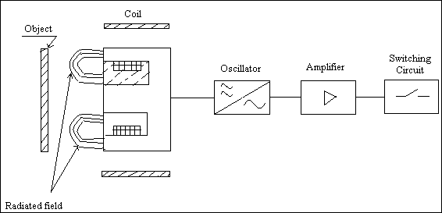

SENSING OBJECT MATERIAL:

The standard inductive proximity switches can sense any metallic (electrically conductive) object. However, there are special types of switches to sense either only ferrous objects or sense only non-ferrous (Cu, Al, etc.) objects.

SENSING ZONE:

These Switches have a dome-shaped electromagnetic field present in front of the sensing area. The switch will sense the object entering into this domain.

SENSING DISTANCE (Sn): This is the distance between the target and the sensing face at which the switch operates. This is usually specified considering M.S.

PLC LOGIC:

Incoming control signals, or inputs, interact with instructions specified in the user ladder program, which tells the PLC how to react with the incoming signals. The user program also directs the PLC on how to control field devices like motor starters, pilot lights, & solenoids. A signal going out of the PLC to control a field device is called an Output.

The objective of the experiment is to mix up two liquids from two different tanks, then the process of heating and mixing takes place in the third tank and then fill up cups on the conveyor assembly automatically by using PLC.

For the execution of this operation, the lower tank must be filled with water upto the LS4 (level switch 4), to 25% of the reservoir. Then fill both the reactant tanks with water upto LS1 & LS2. Place the Metal Cup/Mug at the position in front of Proximity sensor PS1 on the conveyor.

Distance between sensor & Cup wall should be a minimum 3mm so that the PS1 indication lamp glows. Keep Thermostat on 100°C.

When you turn ON all supply switches,

As LS1 & LS2 (Level Switch) gets activated and LS3 (Level switch 3) is deactivated, Solenoid valve SV1 and SV2 turns ON, water started to flow in Mixing Tank & Solenoid valves remains ON till level reaches LS3 (Level Switch 3) in the Mixing Tank.

When the level of the water in the Mixing Tank reaches up to LS3 (Level Switch 3), the Stirrer Motor and Heater is turned ON. After that 5 sec of delay occurs & the solenoid valve situated below the tank is operated and remains in operation till the level goes below LS2 (Level Switch2).

As LS2 (Level Switch 2) level is reached, Solenoid Valve is turned OFF & the Pump is restarted to maintain water level up to LS1.

The Inputs & Outputs used in PLC are,

|  |  |  |
| --- | --- | --- |
| I/P 1: -LS-1  I/P 2: -LS-2 | Level Switch 1  Level Switch 2 | O/P1 Q1: - PUMP ON  O/P2 Q2: - SOLENOID VALVE ON |
| I/P 3: - LS-3 | Level Switch 3 |  |

#### OPERATING PROCEDURE

* 1. Before starting the trainer pour clean water in the respective level tanks to its fullest level marked on the tank.
  2. Switch ‘ON’ the MAINS ON, 24V DC, HEATER ON & STIRRER ON switches.
  3. Keep the small Metal Jar / Mug on a conveyer belt at P.S.-1.
  4. Download Program to PLC using Logo PC-PLC cable & Run the Program.

#### OBSERVATIONS

* 1. According to the program, the fluid will flow from the reactant tank to the process tank through solenoid valves 1 & 2.
  2. When the upper-level switch will reach in the process tank, the solenoid valves will get off.
  3. Then heater and stirrer will start simultaneously, so that the heat will uniformly get distributed in the fluid inside the process tank.
  4. When fluid will get heated at desired temperature level, the heater & stirrer will be turned off.
  5. When proximity sensor 1 will detect the metal glass or vessel, the conveyor will start running in the forward direction through the stepper motor.
  6. When proximity sensor 2 will detect the metal (vessel), the conveyor will stop and the glass or vessel will fill by solenoid valve 3.
  7. After filling the glass or vessel the solenoid valve 3 will be turned off & the conveyor will start again.
  8. When proximity sensor 3 will detect the metal, the conveyor will stop finally.

#### P & I DIAGRAM

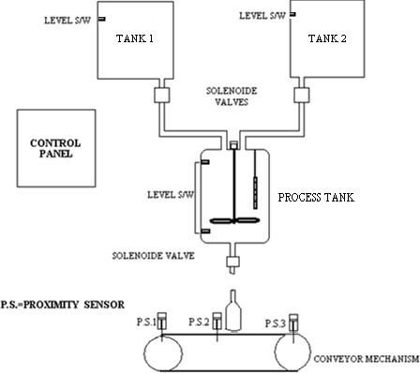

1. **WIRING DIAGRAM**

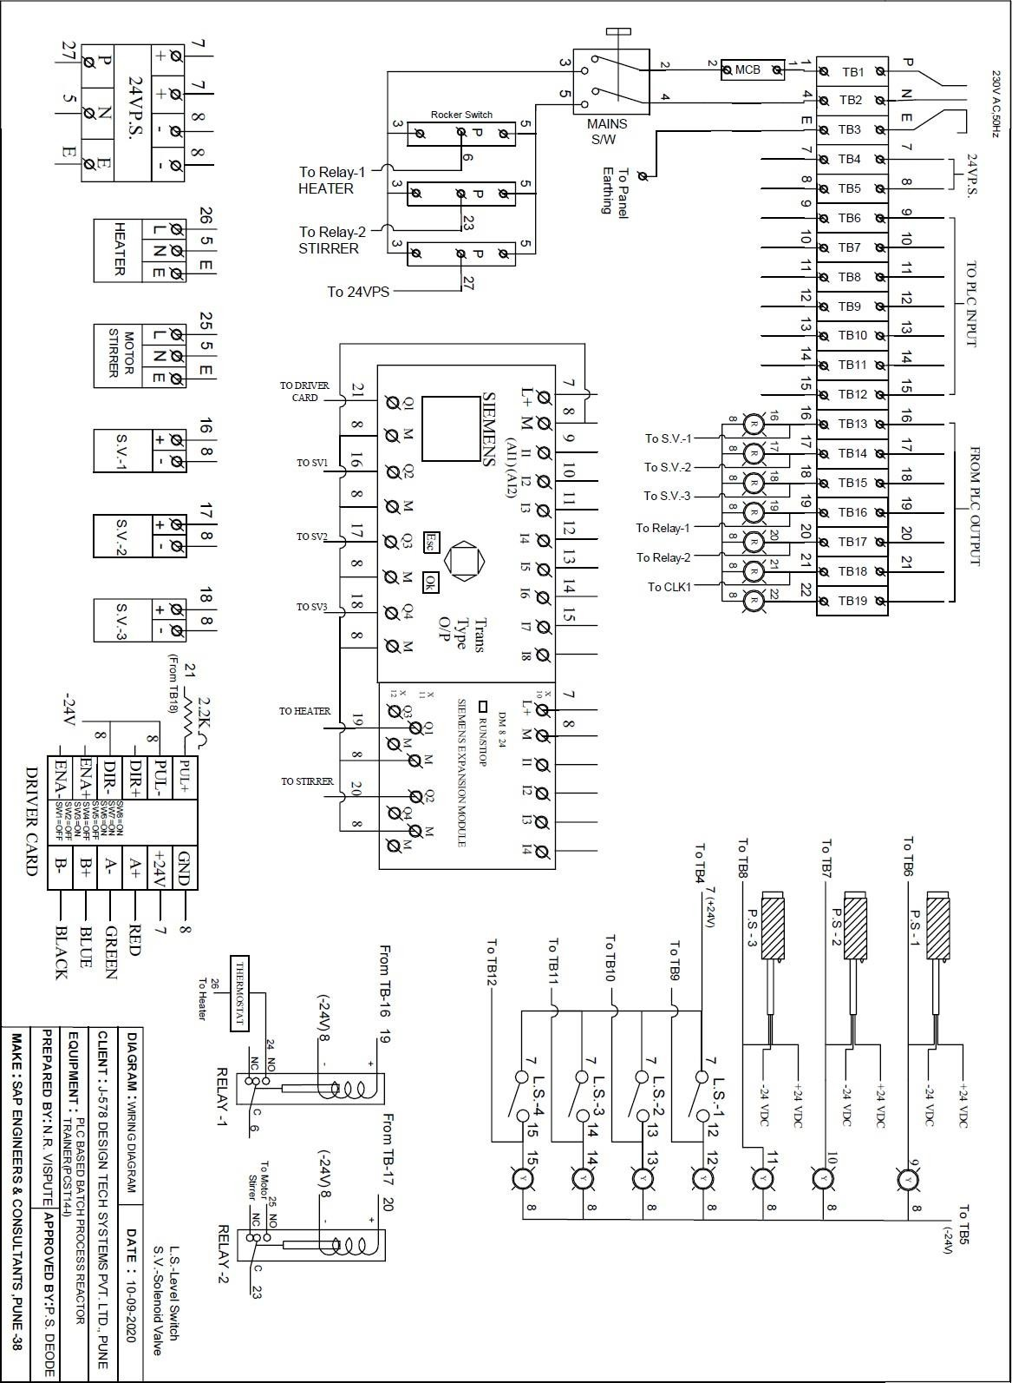

  

#### DO’S AND DONT’S

* 1. Keep the system clean and away from the wet surface.
  2. Take care of PLC, Insert PC-PLC cable carefully.
  3. After performing the experiment, keep the cable in a clean place away from dust.
  4. Make connections as per the wiring diagram.
  5. For troubleshooting refer wiring diagram.
  6. In case of any difficulty contact manufacturer.
  7. Switch off mains supply after practical is completed, without fail.
  8. Do not touch any internal wiring from the backside of the panel unless the mains power is ‘off’.
  9. In any case, don’t modify the program of The PLC without an expert’s advice. Changing the program may lead to the malfunction of the system.